

**Rockbuster Stealth LLC**

**Data Dictionary**

**January 2023**

Table of Contents

1. ERD DIAGRAM 3

2. The fact and the dimension tables in the Rockbuster 4

a. FACT TABLES 4

*Payment 4*

*RENTAL 4*

b. DIMENSIONS TABLES 4

*Store 5*

*Inventory 5*

*Customer 5*

*Staff 5*

*Film_actor 6*

*Film_category 6*

*Actor 6*

*FILM 6*

*Category 7*

*Address 7*

*Language 7*

*City 7*

*Country 8*

# 1. ERD DIAGRAM

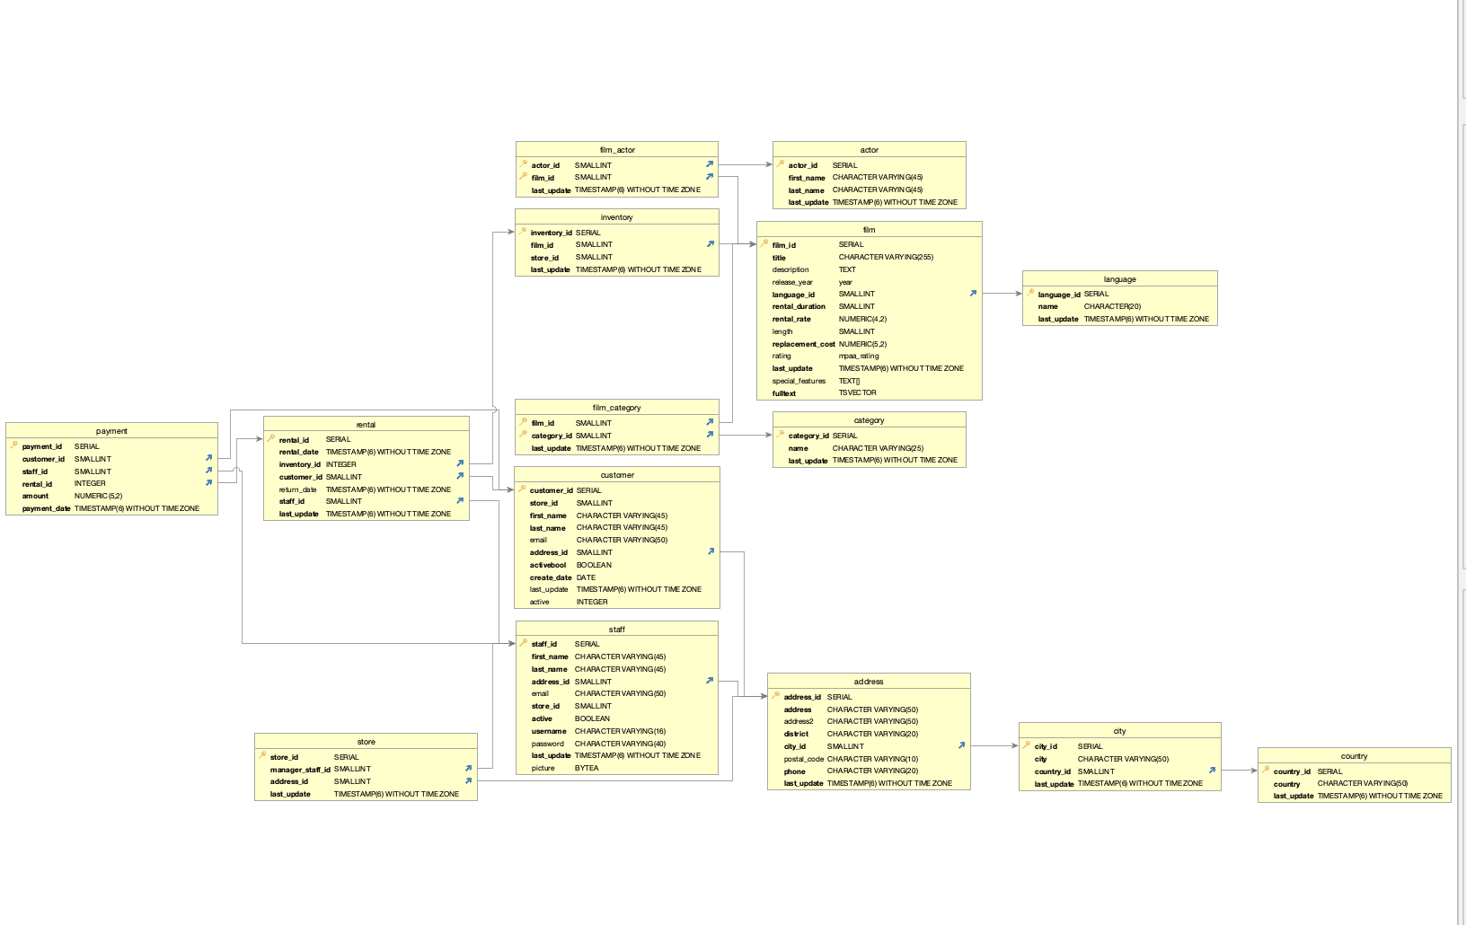

# 2. The fact and the dimension tables in the Rockbuster

## a. FACT TABLES

|  |  |  |  |
| --- | --- | --- | --- |
| TABLE | Columns | Data Type | Description |
| Payment | payment_id (primary key) | SERIAL | Payment ID number |
|  | customer_id | SMALLINT | Customer ID number |
| staff_id | SMALLINT | Staff ID number |
| rental_id | INTEGER | Rental ID number |
| amount | NUMERIC (5,2) | Amount Value USD |
| payment_date | TIMESTAMP (6) WITHOUT TIMEZONE | Payment Date and time without time zone. |
| RENTAL | Rental_id (primary key) | SERIAL | Rental ID number |
|  | Rental_date | TIMESTAMP (6) WITHOUT TIMEZONE | Rental Date and time without time zone. |
| Inventory_id | INTEGER | Inventory id number |
| Customer_id | SMALLINT | Customer ID number |
| Return_date | TIMESTAMP (6) WITHOUT TIMEZONE | Return Date and time without time zone. |
| Staff_id | SMALLINT | Staff ID number |
| Last_update | TIMESTAMP (6) WITHOUT TIMEZONE | Last update and time without time zone. |

## b. DIMENSIONS TABLES

|  |  |  |  |
| --- | --- | --- | --- |
| Table | Columns | Data Type | Description |
| Store | Store_id (primary key) | SERIAL | Store id number. |
|  | Manager_staff_idd | SMALLINT | Manager staff id number |
| Address_id | SMALLINT | Address id number. |
| Last_update | TIMESTAMP (6) WITHOUT TIMEZONE | Last update and time without time zone. |
| Inventory | Inventory_id (primary key) | SERIAL | Inventory id number |
|  | Film_id | SMALLINT | Film id number |
| Store_id | SMALLINT | Sore id number. |
| Last_update | TIMESTAMP (6) WITHOUT TIMEZONE | Last update and time without time zone. |
| Customer | Customer_id (primary key) | SERIAL | Customer id number. |
|  | Store_id | SMALLINT | Store id number. |
| First_name | CHARACTER VARYING (45) | First name. |
| Last_name | CHARACTER VARYING (45) | Last name |
| email | CHARACTER VARYING (50) | Email address |
| Address_id | SMALLINT | Address id number. |
| activebool | BOOLEAN | activebool |
| Create_date | DATE | Create date. |
| Last_update | TIMESTAMP (6) WITHOUT TIMEZONE | Last update and time without time zone. |
| Active | INTEGER | active |
| Staff | Staff_id (primary key) | SERIAL | Staff id number |
|  | First_name | CHARACTER VARYING (45) | First name |
| Last_name | CHARACTER VARYING (45) | Last name |
| Address_id | SMALLINT | Address id number |
| email | CHARACTER VARYING (50) | Email address |
| Store_id | SMALLINT | Store id number |
| active | BOOLEAN | active |
| username | CHARACTER VARYING (16) | Staff username |
| password | CHARACTER VARYING (40) | password |
| Last_update | TIMESTAMP (6) WITHOUT TIMEZONE | Last update and time without time zone. |
| picture | BYTEA | Picture of employee. |
| Film_actor | Actor_id (primary key) | SMALLINT | Actor id number |
|  | Fim_id | SMALLINT | Film id number |
| Last_update | TIMESTAMP (6) WITHOUT TIMEZONE | Last update and time without time zone. |
| Film_category | Film_id (primary key) | SMALLINT | Film id number. |
|  | Category_id | SMALLINT | Category id number. |
| Last_update | TIMESTAMP (6) WITHOUT TIMEZONE | Last update and time without time zone. |
| Actor | Actor_id (primary key) | SERIAL | Actor id number |
|  | First_name | CHARACTER VARYING (45) | First name |
| Last_name | CHARACTER VARYING (45) | Last name |
| Last_update | TIMESTAMP (6) WITHOUT TIMEZONE | Last update and time without time zone. |
| FILM | Film_id (primary key) | SERIAL | Film id number. |
|  | Tittle | CHARACTER VARYING (255) | Tittle of film. |
| Description | TEXT | Description of film |
| Release_year | YEAR | Release year of film |
| Language_id | SMALLINT | Language id number |
| Rental_duration | SMALLINT | Rental duration(day) |
| Rental_rate | NUMBERIC (42) | Rental rate USD |
| Length | SMALLINT | Length of film |
| Replacement_cost | NUMBERIC (52) | Replacement cost USD |
| Rating | MPAA_RATING | rating |
| Last_update | TIMESTAMP (6) WITHOUT TIMEZONE | Last update and time without time zone. |
| Special_features | TEXT | Special features |
| fulltext | TSVECTOR | fulltext |
| Category | Category_id (primary key) | SERIAL | Category id number. |
|  | name | CHARACTER VARYING (25) | Name |
| Last_update | TIMESTAMP (6) WITHOUT TIMEZONE | Last update and time without time zone. |
| Address | Address_id (primary key) | SERIAL | Address id number |
|  | address | CHARACTER VARYING (50) | Primary address |
| Address2 | CHARACTER VARYING (50) | Secondary address |
| district | CHARACTER VARYING (20) | District |
| City_id | SMALLINT | City id number |
| Postal_code | CHARACTER VARYING (10) | Postal code |
| phone | CHARACTER VARYING (20) | Phone number |
| Last_update | TIMESTAMP (6) WITHOUT TIMEZONE | Last update and time without time zone. |
| Language | Language_id (primary key) | SERIAL | Language id number |
|  | name | CHARACTER (20) | Name of language |
| Last_update | TIMESTAMP (6) WITHOUT TIMEZONE | Last update and time without time zone. |
| City | City_id (primary key) | SERIAL | City id number |
|  | city | CHARACTER VARYING (50) | City name |
| Country_id | SMALLINT | Country id number |
| Last_update | TIMESTAMP (6) WITHOUT TIMEZONE | Last update and time without time zone. |
| Country | Country_id (primary key) | SERIAL | Country id number |
|  | country | CHARACTER VARYING (50) | Country name. |
|  | Last_update | TIMESTAMP (6) WITHOUT TIMEZONE | Last update and time without time zone. |